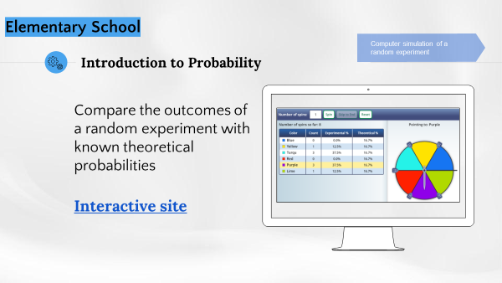
Support Document for the Teacher

Context:
Computer simulation using an interactive site for creating game spinners, and experimentation with activities involving chance.
Method:
This activity can be carried out with the entire class and the simulation projected onto a wall.
Essential knowledge:
Comparing the outcomes of a random experiment with known theoretical probabilities.
Situation conducive to:
Constructing a probability line with the students and discussing the following topics:
  - Predicting the likelihood of an event (certainty, possibility or impossibility)
  - Probability that a simple event will occur (more likely, just as likely, less likely)
  - Comparing the outcomes of a random experiment with known theoretical probabilities
Examples of questions:
- Name an impossible event (probable and certain) in this situation.
  - Place this event on the probability line.
- Is it more likely or less likely that the needle will stop on the blue sector rather than the yellow sector, or is it just as likely that it will stop on either colour? (Change the number of sectors and ask the same question again. In this situation, since the sectors are the same size, the events are just as likely.)
- Without spinning the needle, what is the likelihood that it will stop on the blue sector? (concept of theoretical probability)
  - Place this event on the probability line.
- After 20 spins, keeping in mind the outcomes obtained, what is the likelihood that the needle will stop on the blue sector? (concept of experimental probability)
  - Place this event on the probability line.
- Is the predicted probability equal to that obtained following the random experiment repeated 20 times (relationship between the outcomes of a random experiment and known theoretical probabilities)? For what reasons (concept of chance for each experiment)?

