Support Document for the Teacher
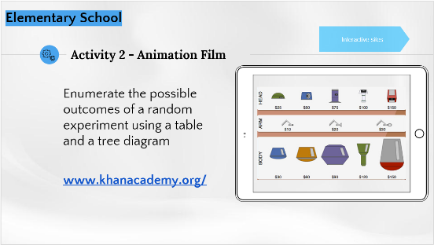
Context:
Making cartoon characters by combining different robot parts,
and representing all the possibilities.

Method:
This exploratory activity can be carried out individually or in teams using technology, or as a presentation to the class.

Essential knowledge:
Enumerating the possible outcomes of a random experiment using a table and a tree diagram.

Situation conducive to:
Using technology to show the possible outcomes and visualize each combination.

Example of an activity below

Student’s name: ___________________________________________________

Step 1 (Click here to access the platform for carrying out this activity.)
Drag the different robot parts onto the screen to make all the combinations of heads and bodies.
- How many different robots can you make?

- How can you quickly count the total number of robots using the table?

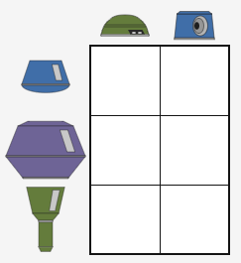

- How many robots can you make if there are 3 different heads and 4 different bodies?

- To carry out more activities of this type, click here.

Step 2 (Click here to access the platform for carrying out this activity.)
Again, drag the different robot parts onto the screen and observe the construction of the tree diagram.
- What did you notice about the tree diagram?

- Make a free-hand tree diagram for this situation, by replacing the illustrations with words.

Tree diagram for making different robot models using 3 heads and 3 bodies

- How many different robots can you make?

Step 3 (Click here to access the platform for carrying out this activity.)
Choose heads, arms and bodies to make a group of 12 different robots with a budget of $300.
- How many heads, arms and bodies did you use to make the 12 different robots?

